**Level 0: Personal Computer Internals**

1. Create a labeled diagram of the inside of a typical personal computer.
   1. You can do it electronically or on paper.
   2. The diagram cannot be a single clip art from the web but may use individual images from the web.
   3. The labels and arrows to the various components must be drawn by you.

The main parts of the computer

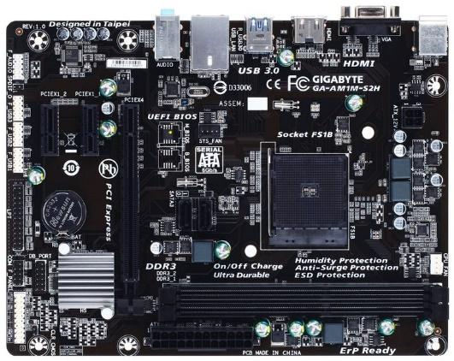

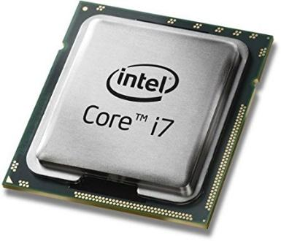

CPU

Motherboard

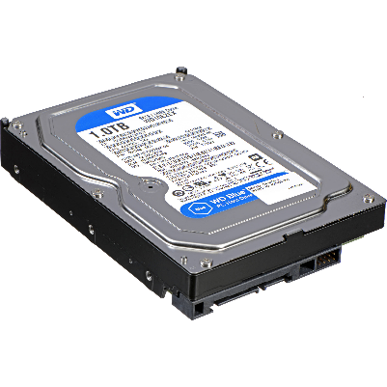

Graphics Card

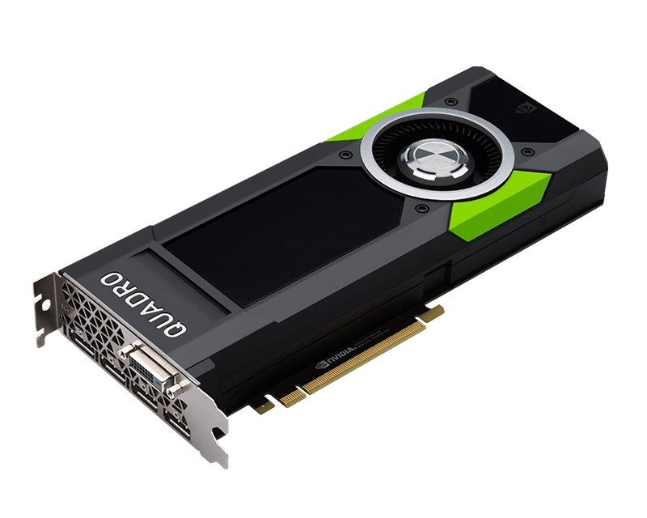

Hard Drive

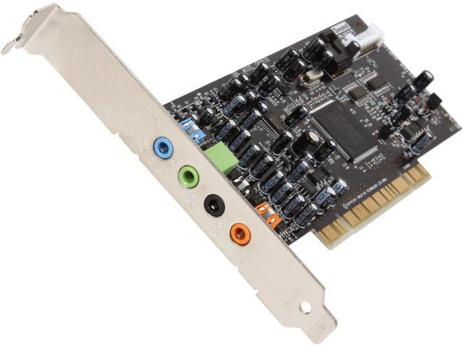

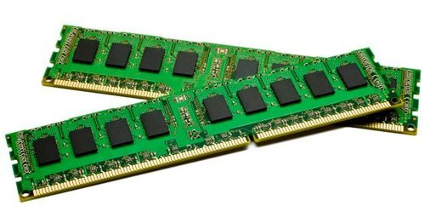

Ram

Sound Card

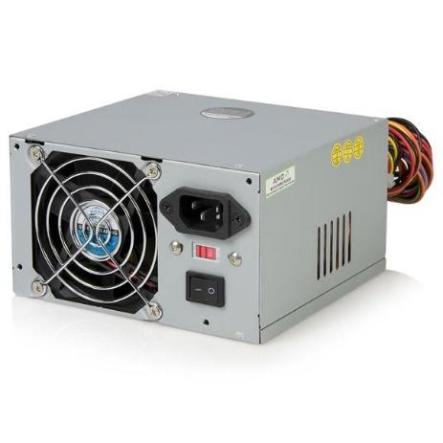

Power Supply

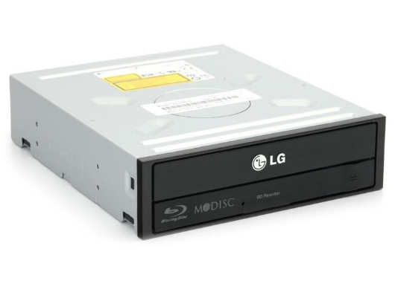

CD Drive

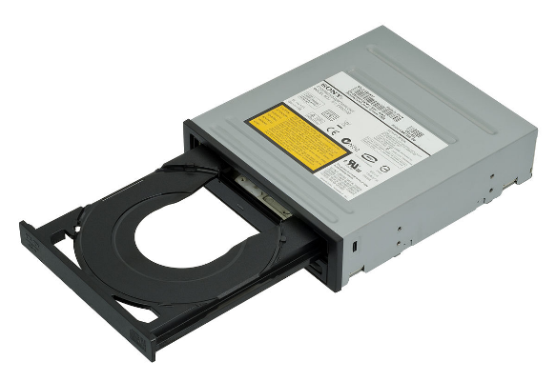

DVD Drive

1. Labeling the Motherboard.
   1. Show the location of the CPU and CPU Fan.

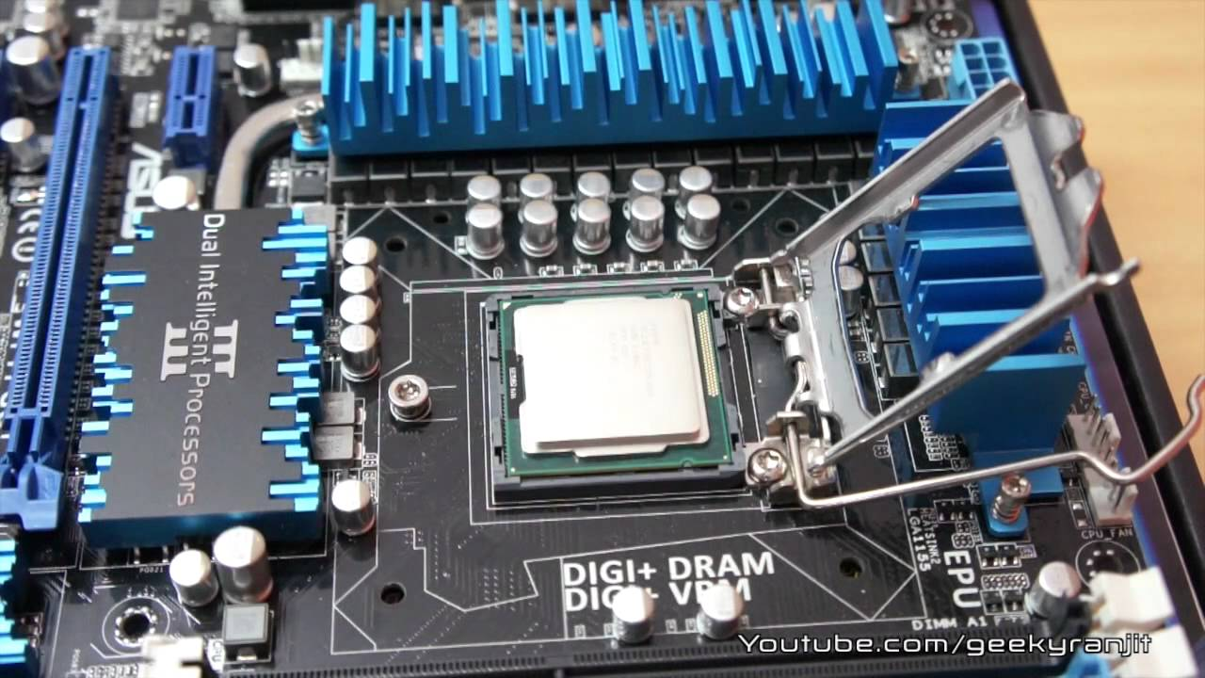

CPU

CPU Fan

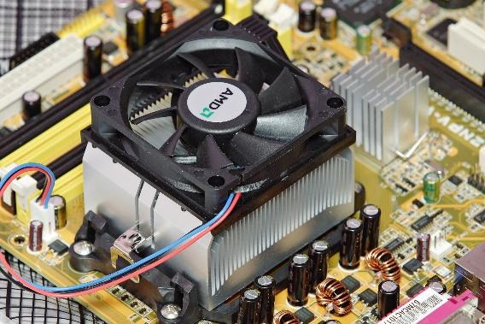

* 1. Show the location of the Memory Slots and RAM Memory

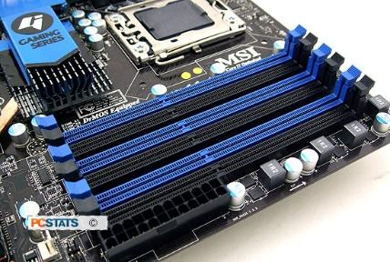

Ram and Memory slots

* 1. Show the location of the on-board video, sound, Ethernet/Wireless and USB devices

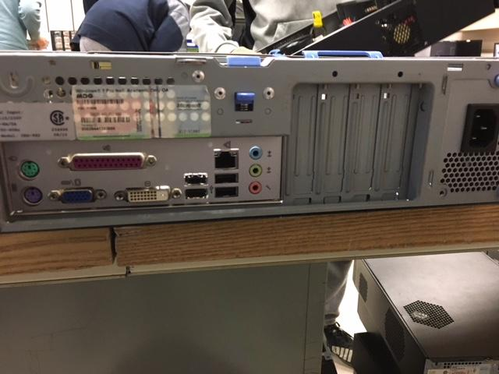

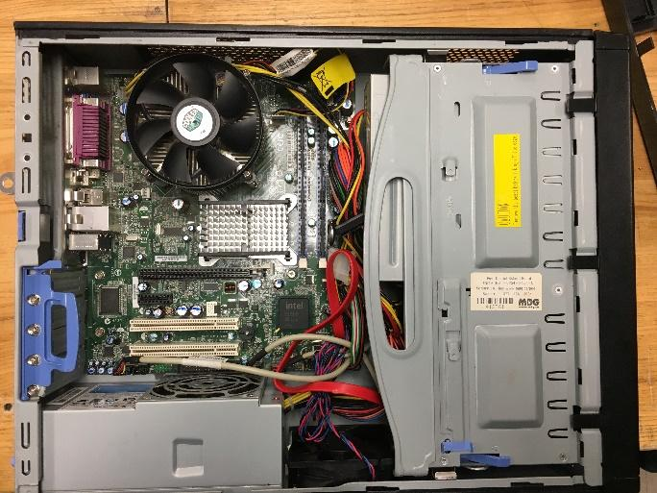

Back Ports with all the devices

* 1. Show the location of the expansion slots and Video and Sound boards.

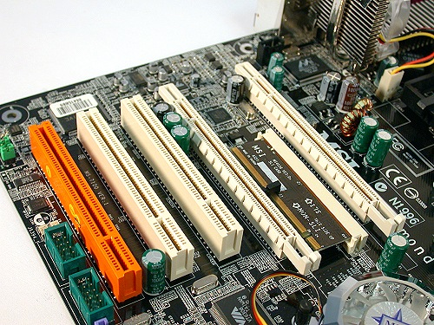

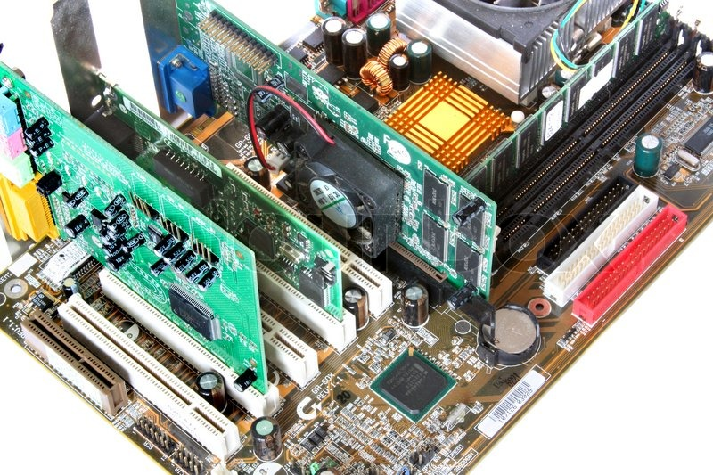

Expansion Slots

Video and sound board.

1. Labeling the Chassis Components.
   1. Show the location of Power Supply.
   2. Show the location of the External Hard Drives and connections to the Motherboard
   3. Show the location of the Removable Media Drives and connections to the Motherboard
   4. Show and label the external connector plate (i.e. where the monitor, keyboard, etc. are connected.)



Power Supply

Removable Media Devices



External Connector Plate

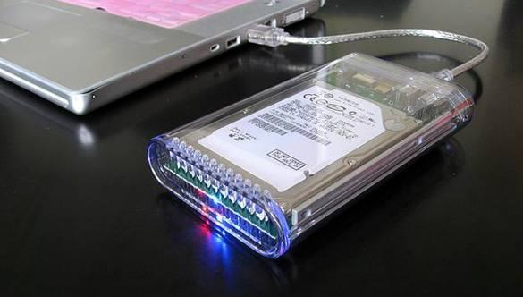

External Hard Drive to Computer

**Level 1: History of Computers**

1. Research the history of “Mainframe Computers”. Make notes on the following:
   1. The first computers (e,g, UNIVAC) and how they were made.

The first mainframe computer was made by IBM in 1944 and it was called the Automatic Sequence Controlled Calculator. This computer solved addition and multiplication in less than 6 seconds and it was operated by a system of vacuum tubes. Another mainframe computer which was one of the first to be made was the UNIVAC which stands for Universal Automatic Computer and the first UNIVAC computer was made on June 14, 1951. The UNIVAC was designed by a person named J. Presper Eckert and John Mauchly. The UNIVAC was able to handle use both numbers and alphabetic characters. Mercury delay lines would store the computer’s program. The UNIVAC was 25 feet by 50 feet, it had 5,600 tubes, 18,000 crystal diodes, and 300 relays.

* 1. Computers in the 1960s and 1970s (e.g. IBM)

Mainframe computers were made by large companies such as IBM, Amdahl and Hitachi.

In 1960 IBM introduced the Stretch computing system. Then in 1962, IBM created the SABRE which stands for Semi-Automatic Business-Related Environment and was a reservation system for the American Airlines. Next in 1963 IBM made the 7094 II which was the most powerful computer at the time. Then in 1964 IBM introduces the System/360 which is a new concept in computers which creates a "family" of small to large computers incorporating IBM-designed Solid Logic Technology microelectronics and uses the same programming instructions. In 1966, IBM started to use Dynamic Random-Access Memory cells which is one-transistor memory cells that stores information as an electrical charge in an electronic circuit. Then in 1967, IBM created the first monolithic integrated germanium circuits. In the 1970s IBM introduced the IBM System/370 in 1970 which is better than the System/360. Then in 1972 IBM announced the System/370 models 125, 158 and 168 Mag Card Executive Typewriter. Next in 1973, made the IBM 3340 disk unit which had more than double the information density on disk surfaces. Then in 1975 IBM introduced the IBM 5100 Portable Computer which was a 50-pound desktop that could be used by engineers, analysts, statisticians, and other problem-solvers. In 1977 IBM made the Data Encryption Standard which is an enciphering and deciphering algorithm. Then in 1978 IBM made the System/38 which was a general-purpose computer that uses new semiconductor technology.

* 1. Modern mainframe computers used by banks, government, and other large companies

The mainframe computer would be used by banks because they allow the banks to process all their data easily. Insurance companies would use mainframes because they have a lot of data to store and process. Healthcare would use mainframes, so that it would keep all their data secure and do the transactions in healthcare. The government would use mainframes to store and analyze the huge amounts of data that the government has. Mainframes help pilots make sure that planes reach their destination in the most effective way because the mainframe would have all the flight networks. Also, retailers would use mainframes to process transactions and keep track of inventory. The mainframe computer that is used by these companies is the mainframe computer which is called Big Iron.

1. Research the history of “Super Computers”. Make notes on the following:
   1. The first super computers (e,g, CRAY) and how they were made.

The first supercomputer was the Control Data Corporation 6600 which was designed ny Seymour Cray and only had a single CPU. It was released in 1964. the CDC 6600 was the size of four filing cabinets. It cost $8 million back in the 1960s which is around $60 million and operated at up to 40MHz. This computer was cooled by Freon that was circulated in pipes. The CPU of the CDC had 10 parallel functional units that and each unit was dedicated to a different task. Another super computer which was one of the first was the Cray 1 and the Cray 1 used integrated circuits. This computer had an increased word size of 64-bit with the performance of 136 megaflops which is faster than the CDC 6600 that had 3-megaflops. The Cray was shaped like a “C” because it improved the performance of the computer because the speed of the modules would be shorter, and it would allow it to have a speed of 80MHz.

* 1. Massively Parallel and Network Computers (e.g. Big Blue)

Massively parallel processing which can stand for MPP is the coordinated processing of a program by multiple processors that work on different parts of the program and each processor is using its own operating system and memory. An "interconnect" arrangement of data paths allows messages to be sent between processors. An MPP system is also known as a "loosely coupled" or "shared nothing" system.

A network computer is a computer with minimal memory, disk storage and processor power and is designed to connect to a network, especially the Internet. The reason there are network computers is that many users who are connected to a network don't need all the computer power they get from a typical personal computer. Instead, they can rely on the power of the network servers.

* 1. Modern quantum computers and how they work

An example of a quantum computers is the Turing machine which was developed by Alan Turing in the 1930s, it is a theoretical device that consists of tape of unlimited length that is divided into little squares. Each square can either hold a symbol (1 or 0) or be blank. A read-write device reads these symbols and blanks, which gives the machine its instructions to perform a certain program. In a quantum Turing machine, the tape and the read-write head exist in a quantum state. Normal Turing machines can only perform one calculation at a time, a quantum Turing machine can perform many calculations at once.

Modern computers, like a Turing machine, work by manipulating bits that exist in one of two states: a 0 or a 1. Quantum computers aren't limited to just two states, they can encode information as quantum bits, or qubits, which can exist in superposition. Qubits represent atoms, ions, photons or electrons and their respective control devices that are working together to act as computer memory and a processor. A quantum computer can contain multiple states simultaneously and it has the potential to be millions of times more powerful than today's most powerful supercomputers.

This superposition of qubits is what gives quantum computers their inherent parallelism. Parallelism allows a quantum computer to work on a million computations at once, while your desktop PC works on one. A 30-qubit quantum computer would equal the processing power of a conventional computer that could run at 10 teraflops which is trillions of floating-point operations per second. Today's typical desktop computers run at speeds measured in gigaflops which is billions of floating-point operations per second.

1. Research the history of “Personal Computers”. Make notes on the following:
   1. When was the first IBM PC introduced and what features did it have?

The first IBM computer was the IBM 5150 and it was introduced on August 1981. This PC was able to process information faster than the mainframe of the 1960s and you can hook up a TV set to it. It would also process text and store more words than a large cookbook. The price of the IBM 5150 was $1,600.

* 1. What were some PCs before the IBM PC?

There were many prototypes before the IBM PC. The prototypes were the IBM 5100 Portable Computer in September 1975 it weighed approximately 50 pounds, the 5100 desktop computer was almost the same to the IBM 1130 storage capacity and it is easy to use as an IBM Selectric Typewriter. After the IBM 5100 was made there were two more models made, which were small computers called IBM 5110 and 5120.

* 1. When was the first Apple introduced and how was it different from the PC?

The first apple computer was introduced in 1975 and it was a box of lights and circuit boards. It connected to a TV as a monitor and a typewriter as a keyboard. This is different from a PC because a PC had a monitor which was not a TV and a normal keyboard.

* 1. How have modern PCs change since the earliest PCs?

The way that PCs have changed over time is that the older PCs were larger in size, the circuits were not sophisticated, and the PCs would overheat a lot. Then, PCs stopped using vacuum tubes and started to use transistors which made the computer faster and overheat less. Also, the PCs were starting to decrease in size because it is using transistors instead of vacuum tubes. Next, the PCs were starting to use integrated circuits which made the PCs a lot faster. Then, in the more modern PCs, the PCs would have better storage and increased speed. Another thing is that in more modern PCs there is a graphics card which is something that old PCs do not have.

**Level 2: History of Computer Components**

1. Research the history of the “CPU Chip”. Make notes on the following:
   1. When was the first CPU chip released (e,g, 8086) and who made it and what did it contain.

The first CPU chip released was the intek 4004 and it was released on November 15, 1971. It was designed by Federico Faggin, Ted Hoff, and Stanley Mazor. The 4004 was a 4-bit, 16-pin microprocessor that operated 740KHz at eight clock cycles per instruction cycle. This chip was capable of 92,000 instructions per second. The CPU had less than 2,300 transistors in it.

* 1. What is an “Integrated Circuit” and how were computers made before ICs?

An integrated circuit is a complete circuit with many components and connections between them, and it is made in a microscopically tiny form on the surface of a piece of silicon. Before the ICs were invented, computers would have used transistors or vacuum tubes.

* 1. How have CPU chips evolved since the 8086?

The CPU chips have been getting faster and getting better performance since the 8086 was made. After the 8086 was made there was a better chip that was made, and it was called the 80286 and the performance of this chip doubled the 8086. The 8086 was made with 134,000 transistors. Then, the Intel 386 chip came out and it had 275,000 transistors and was Intel’s first 32-biit processor. The Intel 386 processor could go up to 4GB of storage. Another chip was made, and it was even better than the Intel 386 chip and it was called the Intel 486. The intel 486 chip had 1.2 million transistors in it and it had up to 4GB of memory.

1. Research the history of “Computer Memory”. Make notes on the following:
   1. How is RAM memory used in PCs different from “Core Memory” used on early computers.

The way that RAM memory is used differently than Core memory in early computers is that RAM would use a hard drive to store the data from the RAM before the computer is powered off. While Core memory would use an electric current to remember the data. So, in Core memory, the data is stored within it and with RAM it is stored on a hard drive.

* 1. What is “Moors Law” and how has RAM memory followed this law?

Moore’s law is an observation that was made by the Intel co-founder Gordon Moore in 1965. In this law he noticed that the number of transistors per square inch on an integrated circuit is doubling each year. Moore’s law would predict this trend will continue in the future. The way that RAM would follow Moore’s law is that memory for computers are getting better as years go on. Also, the memory is getting better so, that computers are not being slow due to that the computers have bad memory.

* 1. How is RAM memory different from external memory (e.g. hard disks)?

The difference between RAM memory and external memory is that in RAM memory it uses electricity to store all the data and when the computer is powered off, all this data is lost. While external memory would save all the data and when let you access the data again instead of deleting it after. Also, the range of RAM sizes would be 256MB to 32GB, while the range of hard disk sizes can be from 500GB to 8TB.

* 1. How has RAM memory evolved over time?

The way that RAM memory evolved over time is that before RAM there was magnetic core memory and then in the late 1960s this was when RAM was invented. People were making changes to RAM by making it fit in smaller places and give it a bigger memory size. Another thing is that there were different types of RAM that were made, and they were Dynamic RAM that used periodic refreshment and it was the type more commonly found on computers. The other type of RAM that was made was Static RAM. Also, in the future people are trying to create a RAM does not erases its data after the computer is powered off.

1. Research the history of “Video Cards”. Make notes on the following:
   1. What is VGA, when was it introduced and what features did it have?

VGA is short for Video Graphics Array and it was a popular display standard. The VGA was developed by IBM in 1987. At that time, it gave 640 x 480 resolution colour displays with a refresh rate of 16 Hz and 16 display colours.

* 1. What came before VGA graphics?

The graphics that were before VGA graphics was EGA and EGA stands for Enhanced Graphics Adapter. The resolution for EGA graphics are 640 by 350 pixels and it had 16 display colours.

* 1. When were 3D graphics cards introduced and what were the first 3D cards like?

The first 3D graphic cards were introduced in 1995 and the first 3D cards were cards that plugged into an expansion slot. The 3D graphics cards acted as pass-through between the main processor and the display

* 1. How have graphics cards evolved over time?

The way the graphic cards are evolving over time is that the performance of these cards is getting better over the years. These cards are getting smaller and more powerful. The appearance and design of the graphic cards have been getting bug changes. The manufacturers have been also upgrading PCB components and experiment with cooling equipment. Some of the early graphic cards were the Monochrome Display Adapter made by IBM in 1981 and it was able to display 80 columns and 25 lines of text. Then in 1983, Intel made the Intel’s iSBX 275 Video Graphics Controller Multimode Board which was able to have a resolution of 256 x 256 with a display of eight colours. In the 1990s they made the 3dfx Voodoo1 in 1996 with a 3D processor that had 4MB of RAM and a 50MHz core clock.

**Level 3: History of Operating Systems**

1. What is a “Operating System”?

The operating system is the most important software that runs on a computer. The operating system would manage the computer's memory and processes. Also, the operating system manages all the software and hardware and, it allows you to communicate with the computer without you knowing how to speak the computer's language. Another thing is that the operating system would make that all the programs would get what they need to work. For example, access to the CPU, memory and storage.

* 1. How is it different from a software program

The difference between an operating system and software program is that an operating system would let you run the computer, manage users and install programs. While a software program is something that is installed onto a compatible operating system.

* 1. What is a “Driver”?

A driver is a group of files that enable hardware devices to communicate with the computer’s operating system. If there were no drivers then the computer would not be able to send and receive correctly to a hardware device.

* 1. What is a “Service”?

A service is a program that would run in the background and in windows it would control many things such as, printing, sharing files, communicating with Bluetooth devices, checking for software updates and many other things.

1. Research the history of the “Windows” operating system. Make notes on the following:
   1. What is DOS and how is it related to Windows?

DOS is short for Disk Operating System and DOS is an operating system that runs from a hard disk drive. The way DOS is related to windows is that when Microsoft first introduced Windows, it was a graphical user interface for MS-DOS and you would have to type “WIN” at the DOS prompt to launch a windows program. Then, Windows changed from a GUI program running under DOS to a full operating system that became a default operating system.

* 1. What was the first version of Windows, when was it released and what did it contain?

The first version of Windows was Microsoft Windows 1.0 and it was introduced in November 20, 1985. Microsoft Windows 1.0 had several programs such as MS DOS file management, Paint, Windows Writer, Notepad, Calculator, Calendar, Card File, a clock, and the game Reversi. Also, Microsoft Windows 1.0 had drop-down menus, scroll bars, icons, and dialog boxes made programs easy to use and learn. Another thing is that to use Microsoft Windows 1.0 it required a minimum of 256 kilobytes which was two double-sided floppy disk drives, and a graphics adapter card. Additionally, it needed a hard disk and 512 KB memory were recommended for running multiple programs or when using DOS 3.0 and higher

* 1. Compare the history of the Apple OS with Windows?

Between the Apple operating system and the Windows operating system there was a lot of competition between the two companies. Apple was known as the first inexpensive and simple personal computer in 1976. Then in 1990, when Windows 3.0 came out it was a more user-friendly and less expensive system than the Mac in the 1990s. Then in 1995 Apple created the Macintosh Clone Program to compete with Windows and IBM. The program allowed a licensed Mac operating system on other computers. This would mean that Windows users can purchase a Mac OS and use it in their PC.

* 1. How has Windows evolved over time?

Windows was first a graphical user interface. Then the first Windows operating system came out in 1985 and it was called Windows 1.0. In 1987 Windows 2.0 came out and it allowed you to overlap applications and it introduced the “Minimize” and “Maximize” options. Then in 1990 Windows 3.0 came out and a few years later in 1992 windows 3.1 came out which was the first series to have a 16-bit operating system. Next in 1995 Windows 95 came out it had a proper marketing drive from Microsoft and it had a “Start” button and taskbar. Then in 1998 Windows 98 came out and it was a hybrid of a 16 and 32-bit operating system. A couple years later in 2000 Windows 200 came out. In 2001 Windows XP came out and it had a more intuitive user interface, better hardware support, and more multimedia capabilities.

1. Research the history of “UNIX”. Make notes on the following:
   1. What is UNIX and what is the history of UNIX.

UNIX is an operating system that created by Brian Kernighan in the 1960s with the members of the MULTICS team at the Bell Laboratories. UNIX is an operating system that is a stable, multi-user, multi-tasking system for servers, desktops and laptops.

* 1. What is LINUX and how is it related to UNIX?

LINUX is an open-source operating system, and this means that it can be modified and distributed by anyone in the world. It is different from other operating systems such as Windows because Windows can only be modified by the company that owns it. While LINUX is free and there are many different versions that you can choose from. The way that LINUX is related to UNIX is that LINUX is a UNIX like operating system that was developed by Linus Torvalds and thousands of other people.

* 1. How is UNIX related to the Apple OS?

The way that UNIX is related to the Apple operating system is that the Apple operating system is based the UNIX operating system. The Apple operating system is a “UNIX-like” operating system.

Works Cited

“1973.” *IBM Archives: 1970s*, www-03.ibm.com/ibm/history/history/year_1973.html.

“A Brief History of CPUs: 31 Awesome Years of x86.” *Pcgamer*, PC Gamer THE GLOBAL

AUTHORITY ON PC GAMES, 14 Apr. 2009, www.pcgamer.com/a-brief-history-of-cpus-31-awesome-years-of-x86/.

Anthony, Sebastian. “Intel 4004, the First CPU, Is 40 Years Old Today.” *ExtremeTech*, 15 Nov. 2011, www.extremetech.com/computing/105029-intel-4004-the-first-cpu-is-40-years-old-today.

Anthony, Sebastian. “The History of Supercomputers.” *ExtremeTech*, 12 Apr. 2012, www.extremetech.com/extreme/125271-the-history-of-supercomputers.

Beal, Vangie. “Network computer.” What is Network Computer? Webopedia Definition, www.webopedia.com/TERM/N/network_computer.html.

Byrne, Michael. “Memory Is Holding Up the Moore's Law Progression of Processing Power.” *Motherboard*, 1 July 2014, motherboard.vice.com/en_us/article/3dkkx8/memory-is-holding-up-the-moores-law-progression-of-processing-power.

Deffree, Suzanne. “Microsoft Ships Windows 1.0, November 20, 1985.” *EDN*, www.edn.com/electronics-blogs/edn-moments/4401825/Microsoft-ships-Windows-1-0--November-20--1985.

“Evolution of Microsoft Windows through the Years.” *1E*, 29 Nov. 2016, www.1e.com/evolution-of-windows/#windows2012.

Fisher, Tim. “What Is a Windows Service and How Do You Use Them?” *Lifewire*, www.lifewire.com/what-is-a-service-4107276.